Testing Plan Summary and Test 1.1 Results

## Team 34: PUCKFish

Team Lead 3: Will Aracri

Victoria Thomas, Alex Neckakov, Peter Ha, Ammar Hussain

# Contents

**Title Page 1**

**Contents** **2**

**Introduction** **3**

**Testing Plan Overview** **4**

**Test Overview** **5**

Test 1: Water-Proofing and Data Collection 5

Test 2.1: IMU Proof of Concept 5

Test 2.2: Sensor Array Test 6

Test 3.1: Port and Enclosure Testing 6

Test 3.2: Full Hardware Test 6

Test 4: Full PUCKFish Test 6

**Test 1.0** **7**

**Introduction and Overview** **7**

**Summary of Procedure and Required Equipment** **7**

**Results** **9**

Conclusion 10

Testing Plan

# Introduction

PUCKFish is a device containing sensors (Temperature, Dissolved Oxygen, Salinity, Current Velocity, Depth, Ambient Light) to be mounted on top of Lobster traps in order to monitor the best possible locations to place traps for maximum catch yield. In order to function, the device must operate under water at depths of up to 1100 feet and then transmit data wirelessly to a base station upon retrieval.

In order to properly test PUCKFish to determine its effectiveness as well as aid in the design interaction process, the team considered the major challenges of the project and then broke them down into testable conditions. These attributes are as listed below.

Major Challenges and Required Testing Capabilities include:

1. Water-proofing: All Enclosures must be tested for water-proofing and then iterated upon to ensure the safety of electronic equipment
2. Sensor Arrays and Related Electronics: All Sensors must be tested with related electronic elements to ensure the required accuracy and precision metrics are achieved
3. Operations Proofing: The PUCKFish must be tested in order to ensure that operation of the device is not only possible, but also achieves a level of simplicity that is required of the customer
4. Novel Current-Velocity Sensing: The PUCKFish uses an IMU and the position of its buoyancy angle to determine current speeds and directions. Because this sensor is novel in design and application, it must be tested to prove that it operates within the proper accuracy and precision per the required metrics

By considering the major challenges above, a testing plan as well as a general technical development plan could be developed and executed.

# Testing Plan Overview

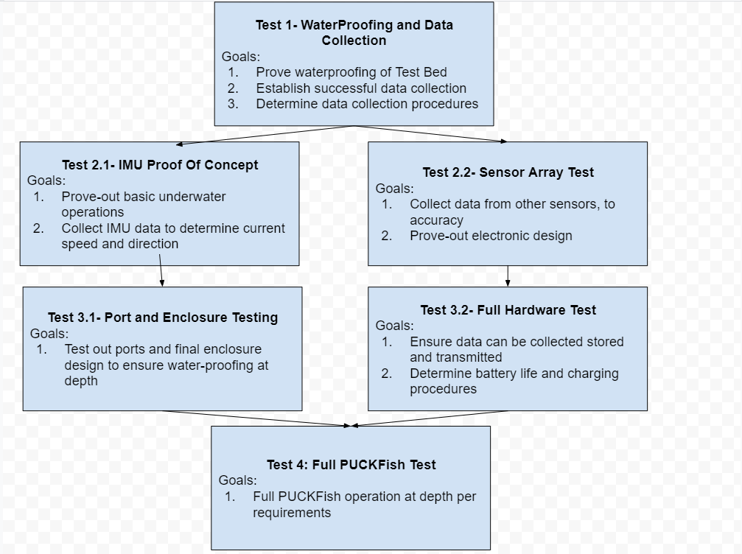

*Figure 1: Testing Plan*

The overall testing plan involves 6 separate tests with goals that build upon each other to achieve the end result of a final operational test with PUCKFish. Included in the testing plan were requirements for the team’s structure as to eliminate blockers and keep work progressing.

The plan involves an initial step proving how the team can come together to perform a successful test. It then moved into two parallel paths that developed the electronic systems and mechanical systems in tandem. By creating parallel paths, the team believes that PUCKFish can be developed in a shorter amount of time while continuously proving out technologies required for the next stage. These small proof of concepts allow for minimal risk in carrying out electronic tests in the water as to limit the possibilities of hardware damage or failures.

Additionally, the goals of each test will be refined as data is collected from tests earlier in the testing plan, allowing for more targeted objectives and quantifiable testing requirements.

Specific procedures for each test will be developed based upon knowledge gained from previous tests. This will allow more streamlined testing as well as refining the actual test environment to achieve the required metrics.

# Test Overview

Each test with their accompanying goals is outlined below. Where applicable, if a test requires data or knowledge from a test prior in the testing plan, a description is provided with how these requirements will be developed.

## Test 1: Water-Proofing and Data Collection

The major goals of Test 1 are as follows.

1. Prove waterproofing of Test Bed
   1. The test bed of the PUCKFish is a waterproof enclosure designed to test systems under-water without development time of producing a final enclosure design. This also shows the mechanical engineering part of the team how to design an enclosure to withstand low-depth submersion in water.
2. Establish successful data collection
   1. Establishing data collection is essential to determine how to transmit data to the base station. In addition, data collection remotely will be of use in later tests where depth is lower and adjustments to the testing environment can be made on the fly without removing the electronics and checking the hardware itself.
3. Determine Data Collection Procedures
   1. By determining data collection procedures, the team can share a common resource that does not require explanation or full team attendance to successfully run a test. This provides faster data collection and more refined technical developments in future tests.

## Test 2.1: IMU Proof of Concept

The major goals of Test 2.1 are as follows

1. Prove-Out basic underwater operations
   1. The IMU test bed will take place in a body of water with some current velocity and at a more significant water depth. This experience will allow the team to better understand how to operate and contend with running tests underwater which will be paramount for further development.
2. Collect IMU Data to determine current speed and direction
   1. After developing a model for how to produce an orientation from IMU data, the team can create models based upon flow around the PUCKFish to determine current speed and velocities. Proving these models work is paramount to the final success of PUCKFish.

## 

## Test 2.2: Sensor Array Test

The major goals of test 2.2 are as follows

1. Collect data from other sensors to accuracy
   1. Collecting the data from the sensors, excluding the IMU, will allow the team to determine how to get data form the sensors and if the sensors achieve the necessary grades of precision and accuracy.
2. Prove-out electronic design
   1. In order to collect data from the sensors, there must be something to read and translate the data to be read. This hardware setup will allow the team to gain experience with building out the necessary electronic set up as well as proving out technology in design.

## Test 3.1: Port and Enclosure Testing

The major goals for test 3.1 are as follows

1. Test out ports and final enclosure design to ensure water-proofing at depth
   1. Using experience from tests 1.1 and 2.1, test 3.1 allows for the testing the enclosure at depth without electronics to determine waterproofing. In addition, somes sensors require exposure to the water surrounding the enclosure, to do this PUCKFish uses ports to the outside. It is important to determine that ports can do this successfully without letting water into the enclosure.

## Test 3.2: Full Hardware Test

The major goals for Test 3.2 are as follows

1. Ensure data can be collected stored and transmitted
   1. The final PUCKFish must be able to store and transmit full data sets. Prior tests do not require this capability, so it must be proved here.
2. Determine Battery Life and Charging procedures
   1. Prior tests do not require the battery life and charging to accomplish them. In order to prove the batteries capabilities, this will be proven here.

## Test 4: Full PUCKFish Test

The major goals for Test 4 are as follows

1. Full Operation at Depth
   1. This test is the final test for PUCKFish. It includes all of the prior test’s requirements and should reach full operation or the path to full operation.

After determining the testing plan and each test and their goals, the team was prepared to run Test 1: WaterProofing and Data Collection

# Test 1.0

# Introduction and Overview

The goals for this test are as follows:

1. Prove Waterproofing Test-Bed
2. Establish Successful Data Collection
3. Determine Data Collection Procedures

In order to accomplish the waterproofing of the test bed, the team decided to put paper towels inside the test enclosure and then submerge the enclosure in a bathtub for a period of time. The enclosure would be tested overnight and then reviewed to see if any of the paper towels within the enclosure is damp. Given no dampness, the team could move on to accomplish goal 2.

In order to accomplish successful data collection, the team got a micro controller and the IMU that will be used for Test 2.1. In addition, the team set up a radio that can be used to beam the information back to a computer while the microcontroller is inside the test enclosure. IMUs determine acceleration data, which then can be used to determine the orientation by modeling the location of the gravity vector. This information will serve as the data the team will try to successfully collect.

In order to establish successful data collection, the team started a google sheet to begin writing procedures that could be updated and also be used to record data in. After creating this sheet and having the general list of things to do, the team began to write the procedure for the IMU testing.

# Summary of Procedure and Required Equipment

The team submerged the enclosure overnight. After determining confidence in the water proofing of the enclosure, the following procedure was written on the data collection and procedure spreadsheet.

| **OP 1: SETUP** |  |
| --- | --- |
| Op | Description |
| 1.1 | Connect Prototype board to laptop |
| 1.2 | Confirm Battery levels exceed 50 percent |
| 1.3 | Install prototype board onto prototype chassis |
| 1.4 | Begin collecting data by starting up the imu, Record the start time in the notes |
| 1.5 | Wrap teflon tape on threading, clockwise |
| 1.6 | Buyoff that housing is prepared for submerging, Check for potential leak areas |
| **OP 2: TESTING PROCEDURE** |  |
| OP | Descrition |
| 2 | Submerge the Prototype in some volume of water so that it is totally submerged |
| 2.1 | Begin running the code for IMU according to best practice |
| 2.2 | Using a protractor, angle the housing parallel to gravity vector, Record start time and end time in notes |
| 2.3 | Using a protractor, angle the housing 45 degrees against gravity vector, Record start time and end time in notes |
| 2.4 | Using a protractor, angle the housing perpendicular to gravity vector, Record start time and end time in notes |
| 2.5 | Remove the prototype from the volume of water |
| **OP 3: BREAKDOWN PROCEDURE** |  |
| OP | Description |
| 3 | Dry off the outside of the prototype so that it is no longer wet |
| 3.1 | Open the prototype housing |
| 3.2 | Remove chassis from the housing |
| 3.3 | Shutdown pcb per best practice |
| **OP 4: DATA COLLECTION AND ANALYSIS** |  |
| OP | DESCRIPTION |
| 4 | export data to a text file |
| 4.1 | Separate Data via the timestamps collected in ops 2.3-2.6 |
| 4.2 | Gather Averages of the data given in "TEST 1, DATA ANALYSIS" in this google sheet |

*Table 1: Procedure as Outlined*

After the procedure had been written the test could be run. However, after realizing that water could not be procured in the Senior Design lab during the test, the team decided to omit the underwater active portion of this test. Instead, this portion was performed after the data collection with success. In addition, by reviewing the data, it was determined that only a couple sample seconds from the test would be required, not orientation, to determine the path forward

Listed below are the equipment requirements of the Test. This equipment was only listed for the active data collection portion of the lab as the other portions wrapped into the test were completed prior to the display in the senior design Lab.

| **REQUIRED MATERIALS** |  |  |
| --- | --- | --- |
| Item | Name | Quantity |
| 1 | PUCKFish Prototype board V0.1 | 1 |
| 2 | PUCKFish Prototype Housing V0.1 | 1 |
| 3 | PUCKFish Prototype Chassis V0.1 | 1 |
| 4 | Laptop (any) | 1 |

*Table 2: Materials List*

# Results

During the test, the IMU and microcontroller were placed into the enclosure. While moving the IMU around inside of the enclosure, the IMU data was presented on the screen as serial output, showing a successful collection of data. The timestamps of the collection were recorded and the text file was saved locally to the computer and then transferred to the google sheet. Shown below is a table with the data

| Time | Accel X | AccelX | Accel Y |
| --- | --- | --- | --- |
| 86.71 | -0.32 | -9.39 | -9.39 |
| 90.74 | -0.42 | -9.5 | -9.5 |
| 92.75 | -0.35 | -9.46 | -9.46 |
| 94.76 | -0.21 | -9.5 | -9.5 |
| 96.78 | -0.87 | -8.99 | -8.99 |
| 98.79 | 9.94 | 0.32 | 0.32 |
| 100.8 | 9.58 | 0.58 | 0.58 |
| 102.82 | 9.54 | 0.74 | 0.74 |
| 104.83 | 9.46 | 0.68 | 0.68 |
| 106.85 | 9.39 | 1.17 | 1.17 |
| 108.86 | 9.32 | -2.01 | -2.01 |
| 110.87 | 9.68 | 0.42 | 0.42 |
| 112.89 | 9.42 | -0.02 | -0.02 |
| 114.9 | 9.39 | 0.5 | 0.5 |
| 116.91 | 9.24 | 0.34 | 0.34 |
| 118.93 | 9.91 | 0.86 | 0.86 |

*Table 3: Test Results*

## Conclusion

Through reviewing the acceleration data, the format and data collection methods were determined as a success. By testing the enclosure in the bathtub, the water proofing portion of the test was also successful.

From the results of this test, it was determined that the best path forward is to begin modeling the gravity vector as well as buoyancy characteristics to form the quantifiable requirements for Test 2.1. The IMU showed response to orientation being changed rapidly with high fidelity as shown by time stamps 86s to 96s. In addition, by keeping the enclosure still, the IMU showed good results providing a steady value within the required amount of precision between times 98s and 118s.

The team also adjusted how data is collected, by using methods to separate strings from numbers using google sheets as opposed to a separate script written in MATLAB. From the results of the test, one portion of the team will get to work developing the model for the IMU Current test and another portion of the team will begin working on the sensor array for Test 2.1.

The team has accomplished the goals of Test 1.1 and feel confident in proceeding to the tests outlined in the plan discussed.